Lab Assignment 3: Practicing SQL queries using Operators, Aggregate and Scalar functions
Objective: To solve simple queries using SQL operators, Aggregate functions and Scalar functions over tables based on assignment 1.
1. Write the SQL Expressions for the following queries using suitable SQL operators.
a) Display the account numbers, account types, and balances of accounts that belong to any of the following branch codes: B001, B002, B003, and B005.
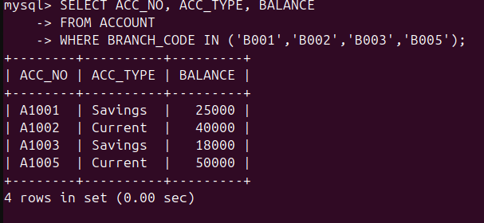
b) Display the records of customers whose names start with the letter ‘A’ and who live in the city of Delhi.
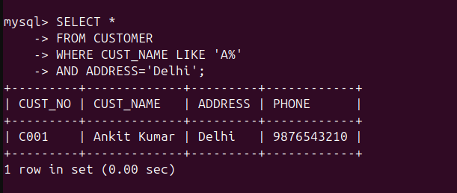
c) Display customer number, account number, original balance, interest amount, and final balance by calculating 5% interest on the account balance.

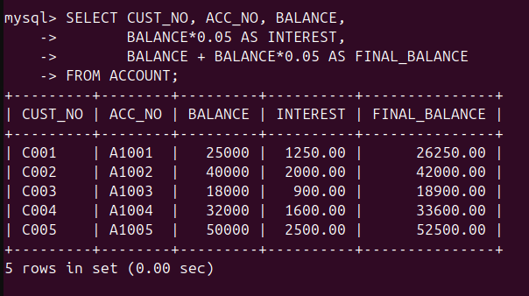
d) Display the records of accounts having balance in the range 20000 to 50000.
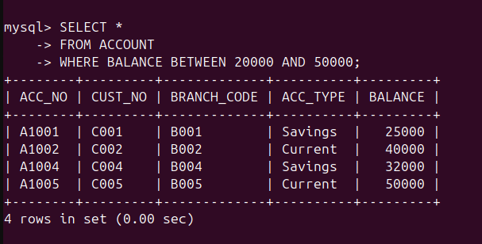
e) Display the records of customers having the second letter in their name as ‘m’.
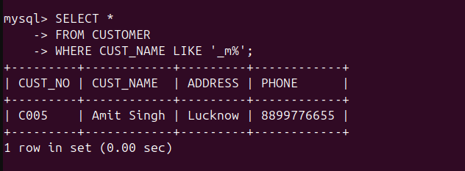
f) Display the account numbers of Savings accounts, sorted in descending order of their account balance.
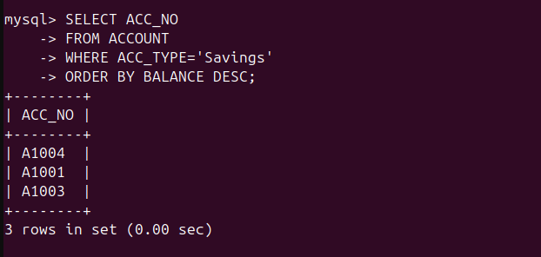
g) Update all records of the ACCOUNT table by increasing the account balance by 10%.
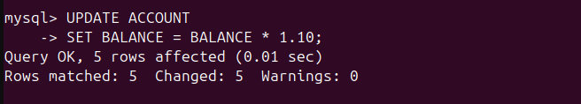
h) Update the account balance by 5% for Savings account holders whose balance is less than 25000.
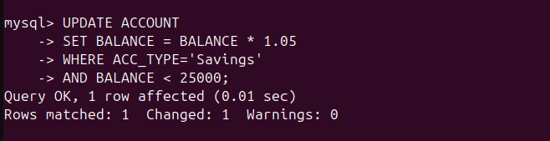
i) Display the annual interest amount for each account by calculating interest at 6% per annum.
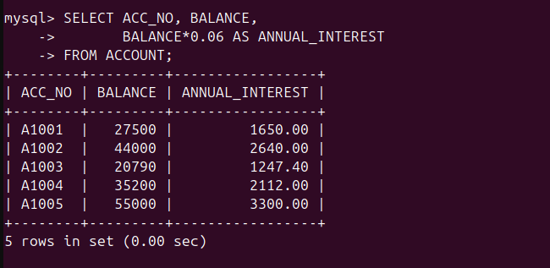
j) Update the account type from ‘Current’ to ‘Savings’ for accounts having balance less than 45000.
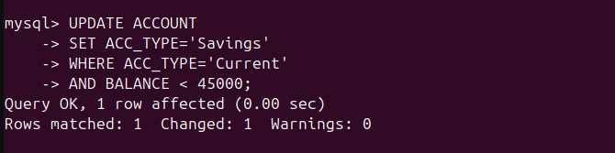
k) Delete the record of the customer having loan amount less than 150000.
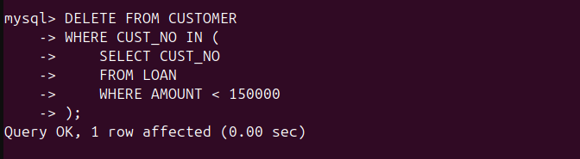
l) Delete the customer records whose names end with the letter ‘h’.

2. Write the SQL Expressions for the following queries using suitable SQL aggregate function.
a) Display the average account balance of accounts with the account type ‘Savings’.
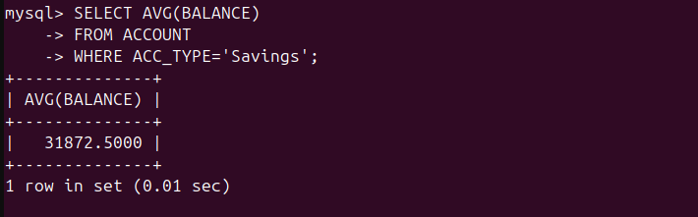
b) Display the transaction type and the average transaction amount of transactions performed by users.
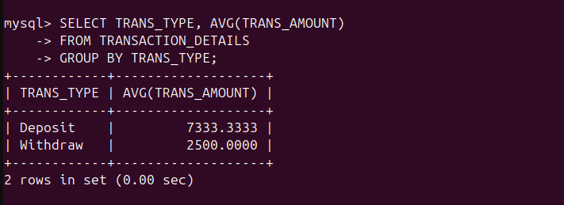
c) Display the account number, customer number, and balance of the account having the highest balance.
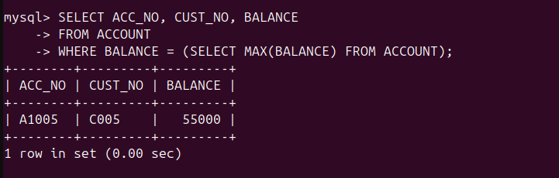
d) Display the total number of customers belonging to the cities Delhi or Mumbai.
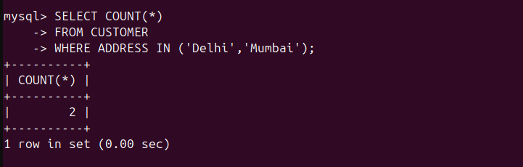
e) Display the total loan amount taken by customers from branch code B001, B002 and B004.
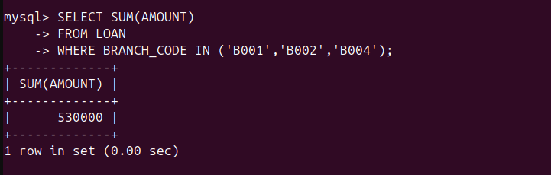
f) Display the account type, the number of accounts, and the total account balance for each account type.
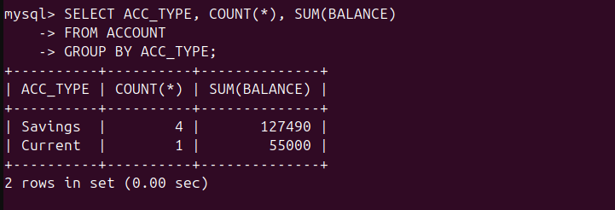
g) Display the transaction type and the total transaction amount for each transaction type,excluding the account number ‘A1005’.
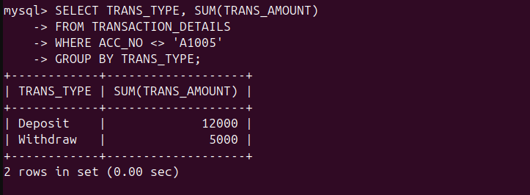
h) Display the total account balance of all accounts with the account type ‘Current’.
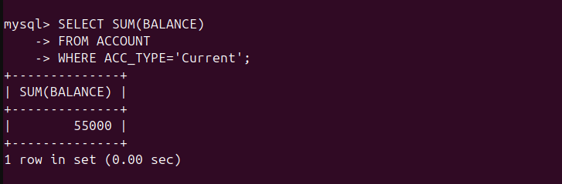
i) Display the number of accounts for each account type sorted in increasing order.
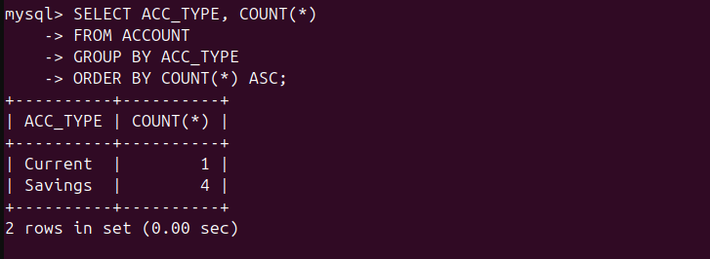
j) Display the number of transactions for each transaction type in descending order.
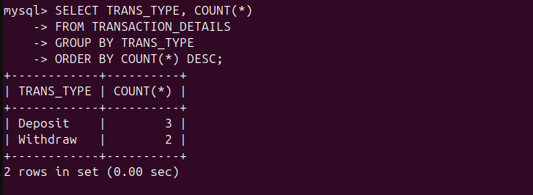
k) Display the account type and average account balance, but only for account types whose average balance is greater than 25000.
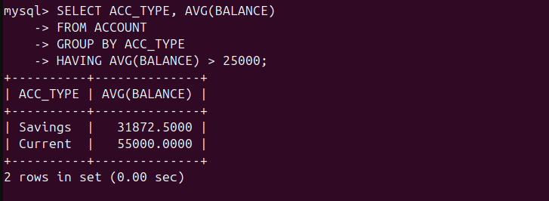
l) Display the account type and number of accounts, but only for account types having more than two accounts.
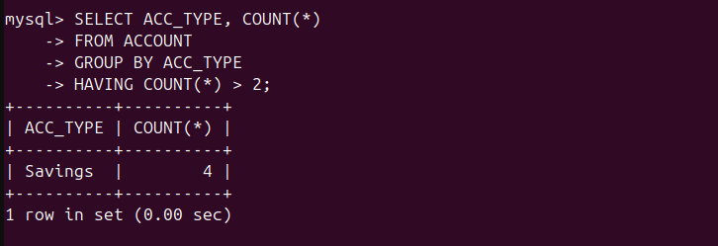
m) Display the account type and maximum account balance for each account type, but only for account types where the maximum balance is greater than 40000.
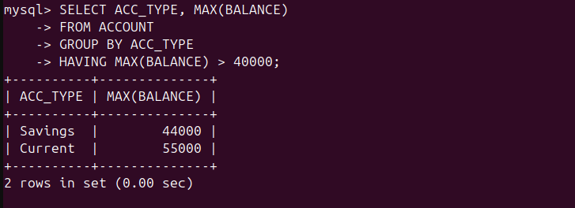
n) Display the highest account balance among Savings accounts.
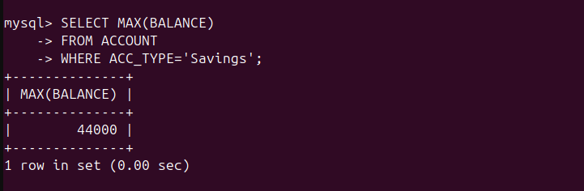
o) Display the transaction type having the highest total transaction amount. (Optional)
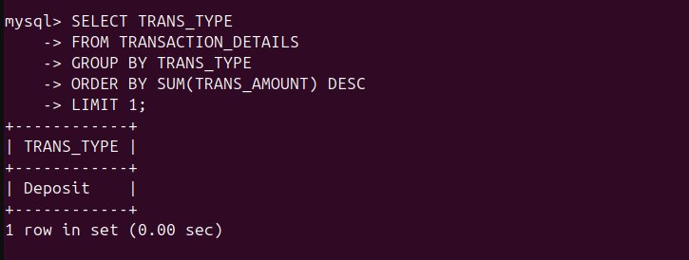
p) Display the account types whose total account balance is greater than the average account balance of all accounts. (Optional)
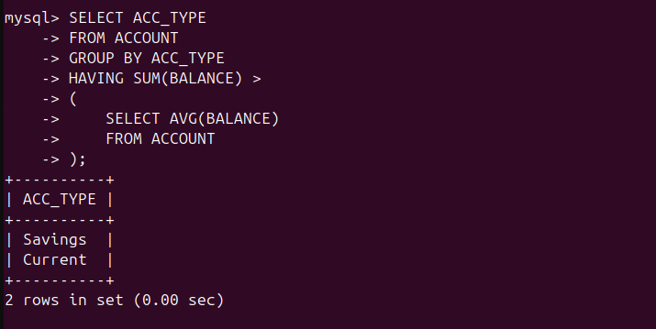
3. Write the SQL Expressions for the following queries using suitable SQL scalar function.
a) Display 2nd- 6th characters of your name.
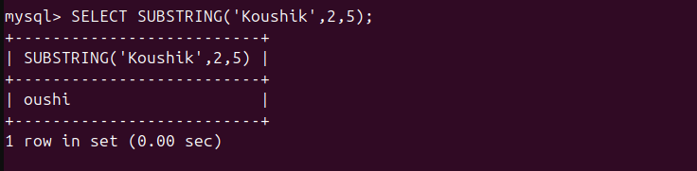
b) Find length of your full university name.
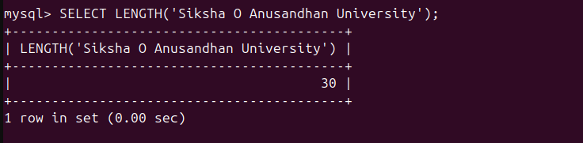
c) Display all the customer names in upper case.
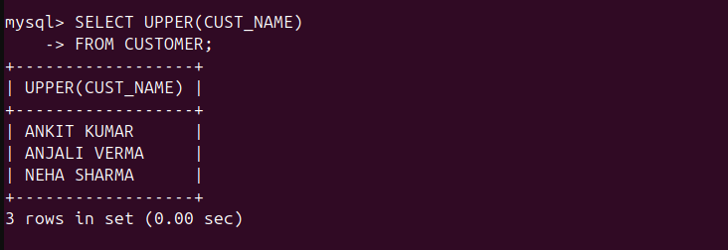
d) Display the account type of each customer as a two letter code.
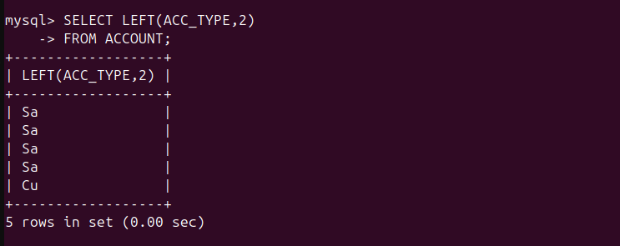
e) Display the month and year of the transaction perform by each customer.
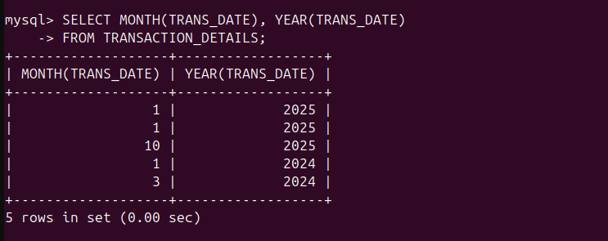
f) Display the transaction date of each customer in dd/mm/yyyyy format.
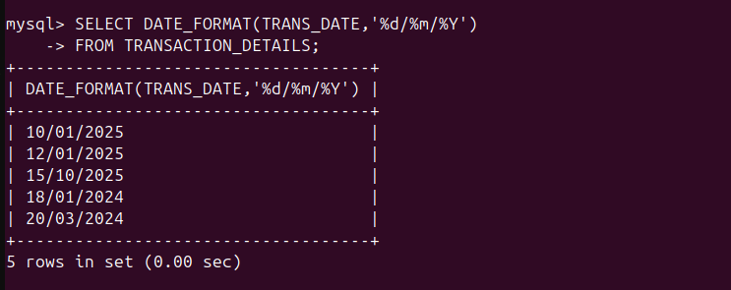
g) To calculate the exact age of each transaction relative to the current date in term of years,months and days.
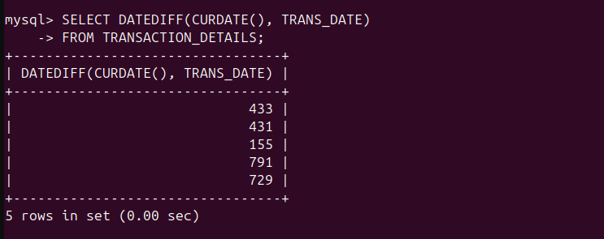
h) Display the date corresponding to 15 days after today's date.
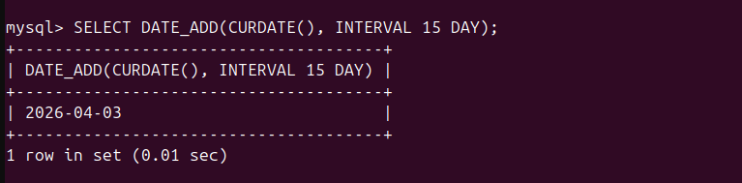
i) Display the value 94204.27348 truncated up to 2 digits after decimal point.
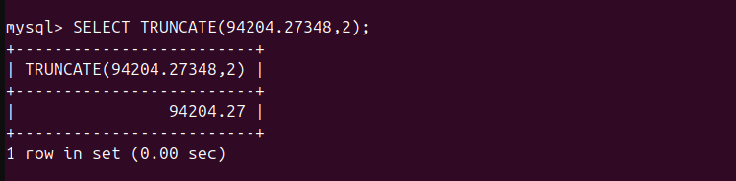
j) Display the value of the expression 5 + 89.
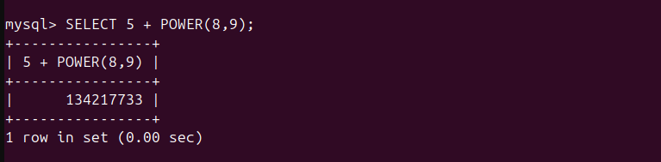
k) Find out the square root of 6464312.
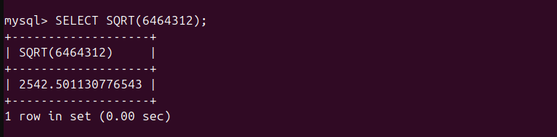
l) Display the string “HELLO ITER” in lower case with a column heading lower case.
